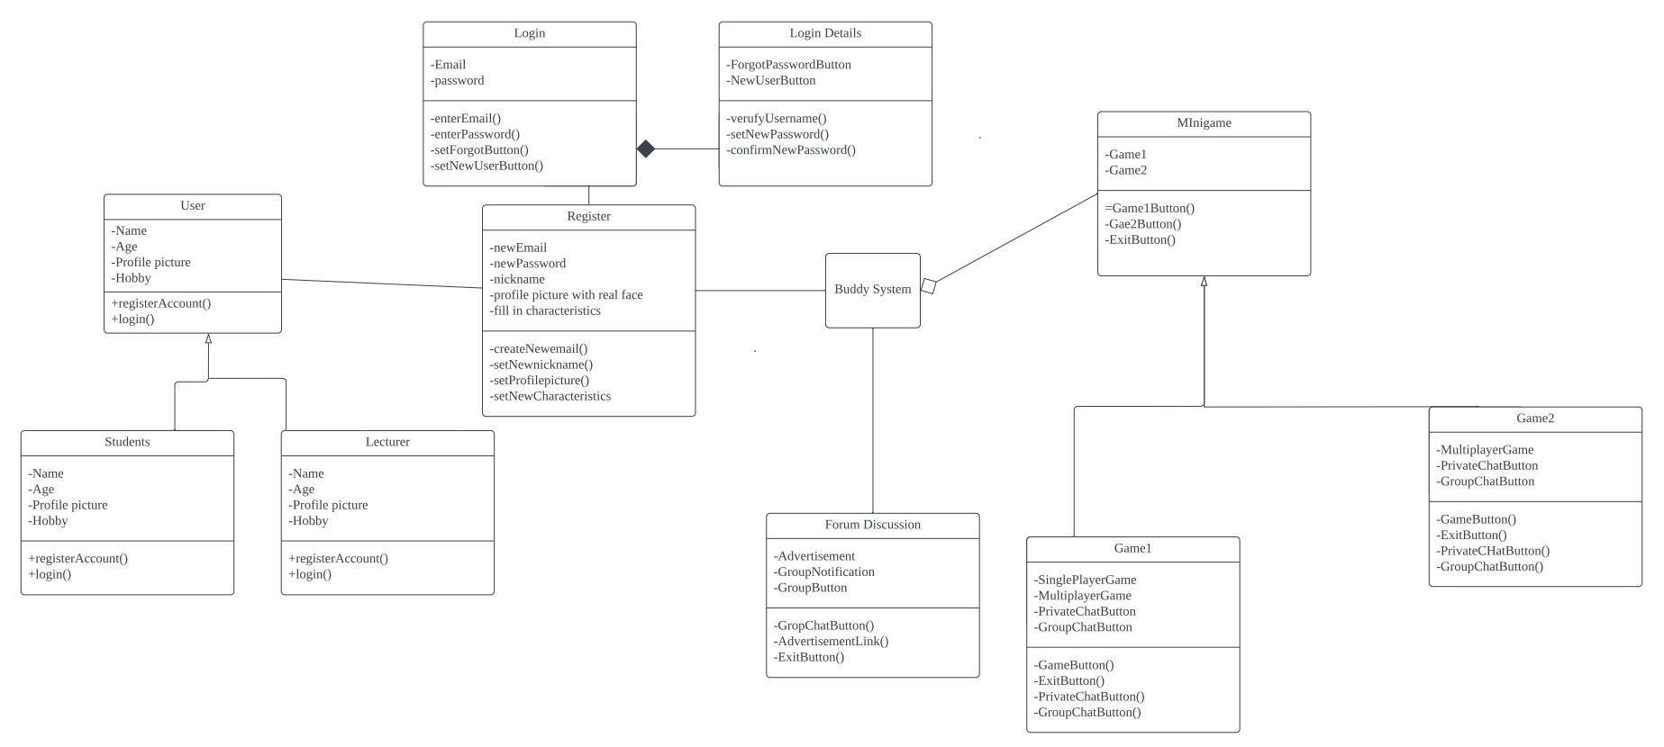

The design pattern that I chose to do this class diagram is from Structural patterns which is composite design pattern . This is because this method able to assort the complex data to a simple class diagram .